SOC L1 Alert Triage - Lab Report

Date: 29/06/2026
Difficulty: Easy
Category: SOC Internals
Platform: TryHackMe

Overview

This lab looks at what alerts are and how level 1 SOC analysts deal with alerts by investigating the alert properties and triaging them accordingly. This lab also includes a practical example of viewing alerts triaging them as either true positive or false positive.

2. What I did

Knowing how to handle alerts properly decides whether a security breach is identified and mitigated or missed and damaging. First of all, an event must happen such as a user login, file download or process launch and then the system like a firewall or operating system needs to log the event. All system logs are then entered into a security solution like a EDR or SIEM. An alert is a notification generated by a security solution when a specific event or sequence of events happens. Analysts then triage numerous alerts per day instead of looking through millions of logs.

As a SOC level 1 analyst they are the first line of defence and the ones who must deal with the highest number of alerts on a daily basis. They will review alerts, decide if it is good or bad and notify the level 2 analysts if they think it could be a real threat. Level 2 analysts then receive these alerts and perform deeper analysis and investigation.

Alert properties:

- Alert time – shows the alerts creation time, usually a few mins after the actual event
- Alert name – summary of what happened, based on the detection rules name
- Alert severity – defines the severity of the alert, low to critical
- Alert status – states if someone is working on the alert or the triage is done
- Alert verdict – explains if the alert is a real threat or just noise
- Alert assignee – the analyst that was assigned to the alert
- Alert description – describes the alert
- Alert fields – comments from SOC analyst

Alert prioritisation is the process of deciding which alert to deal with first and in which order as it is important to ensure that high risk alerts are dealt with swiftly as they pose the biggest threat. Make sure you don’t take an alert that is already being worked on by another analyst, sort them by severity score so deal with high/critical risk alerts first and also sort by time to deal with the oldest alert as they could be deep into stealing data whereas a new alert might just be discovering the system and you would have time to stop them later. For example, the “Potential Data Exfiltration” alert will be first priority as it is not being worked on yet and it has the highest severity.

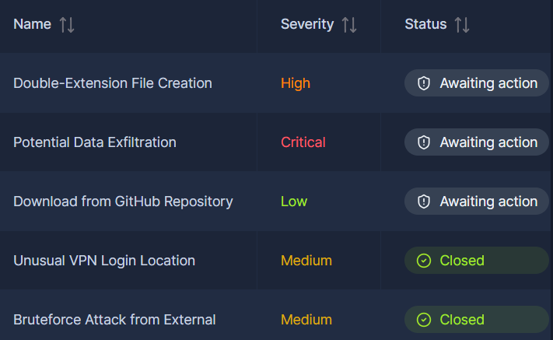

Alert review or alert triage is the next step of the process. You need to start by assigning yourself the alert, moving it to in progress and then read the alert details such as the name, description and key indicators. Level 1 analysts often use workbooks or playbooks which are instructions on how to investigate the specific category of alerts. However, if they are not available then it is advised that you understand who is under threat, find the action described in the alert such as suspicious login, look for suspicious alerts around that one and finally use threat intelligence platforms to help think about the alert. Next you need to decide whether the alert is malicious (true positive) or safe (false positive) and write up a detailed comment outlining analysis steps and verdict reasoning and close the case.

Practical

This practical will look at the 3 most severe alerts and I need to triage them accordingly using the steps discussed above.

Alert 1 – Potential Data Exfiltration

Below are the details of the alert which show that it is zoom calls and is not suspicious

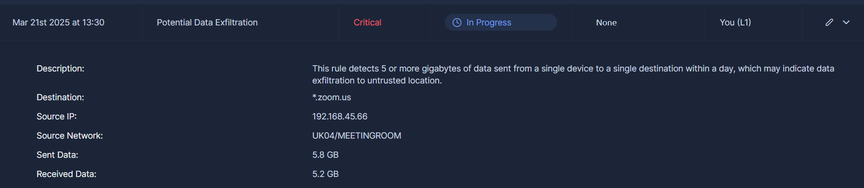

To triage this, I need to give the verdict as false positive and the comment as to why

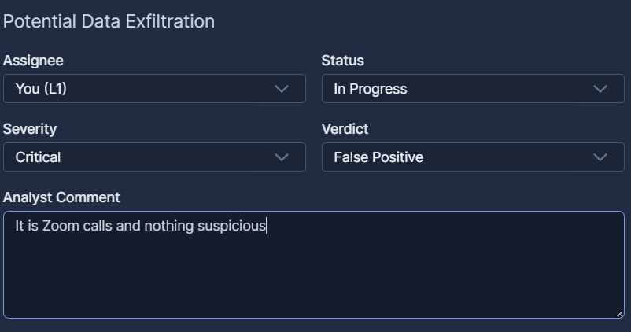

Alert 2 - Double-Extension File Creation

The details of this alert show that the file has a double-extension file type of mp4.exe which is suspicious

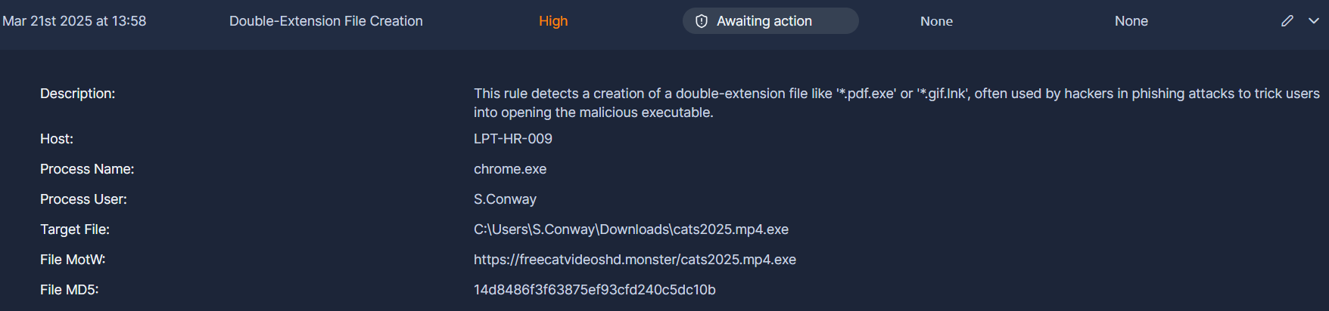

To triage this, I give the verdict as true positive and the comment as to why

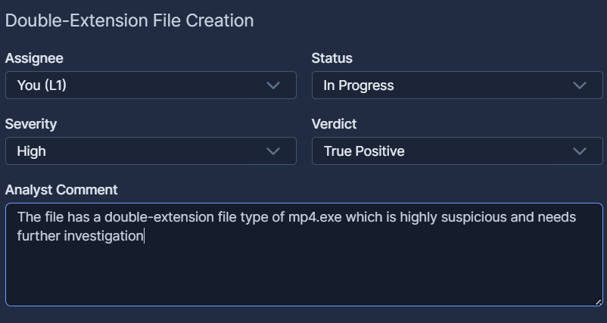

Alert 3 – Download from GitHub Repository

The details of this alert show that the URL is a legitimate GitHub page and when you navigate to that URL, it is a developer GitHub page which is not malicious.

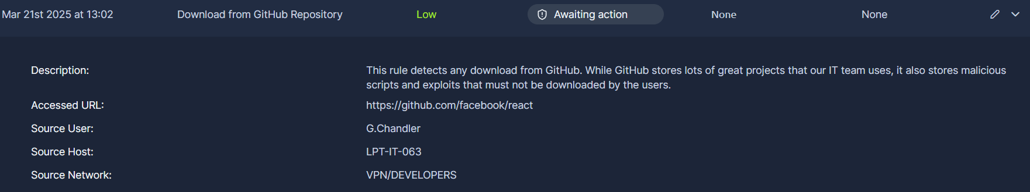

The triage is as follows

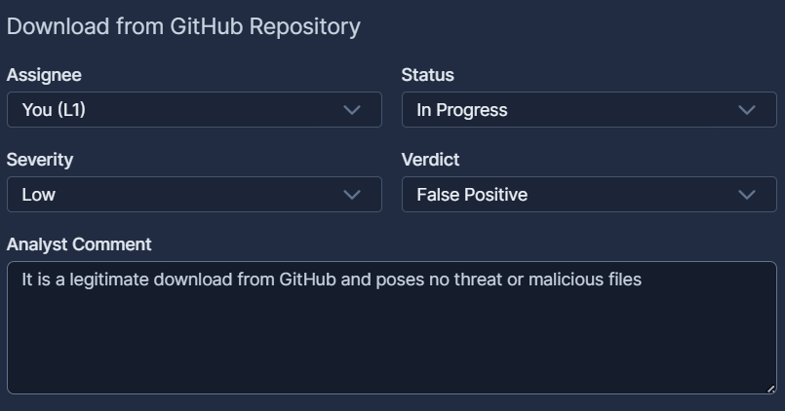

3. What I’ve learned

- What alerts are
- Alert properties
- The correct process for alert triage
- Practical examples of investigating alerts and triaging them appropriately

